Outputs
.
Output 1: Depletion Width as a Function of Gate Voltage — N+ Poly gate, P-type silicon.
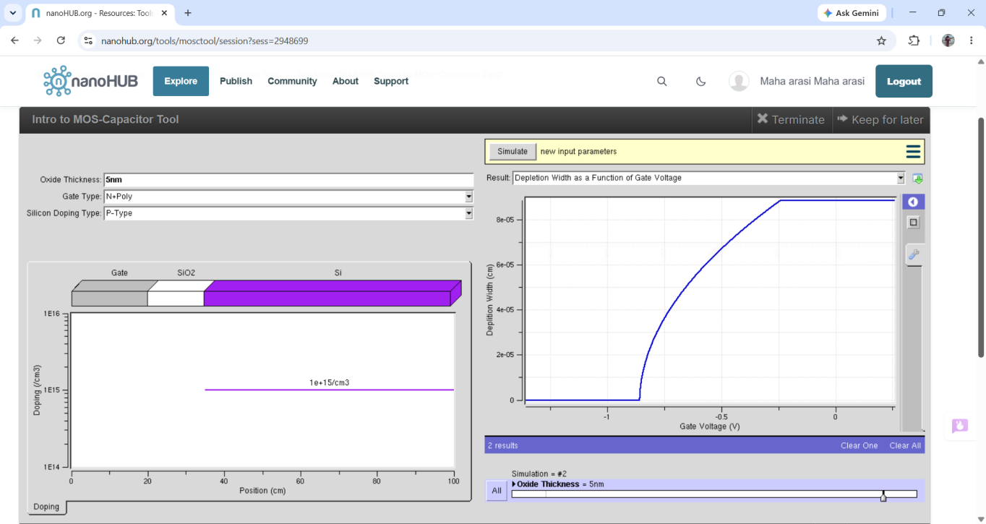

Output 2: Surface Potential as a Function of Gate Voltage — N+ Poly gate, P-type silicon.
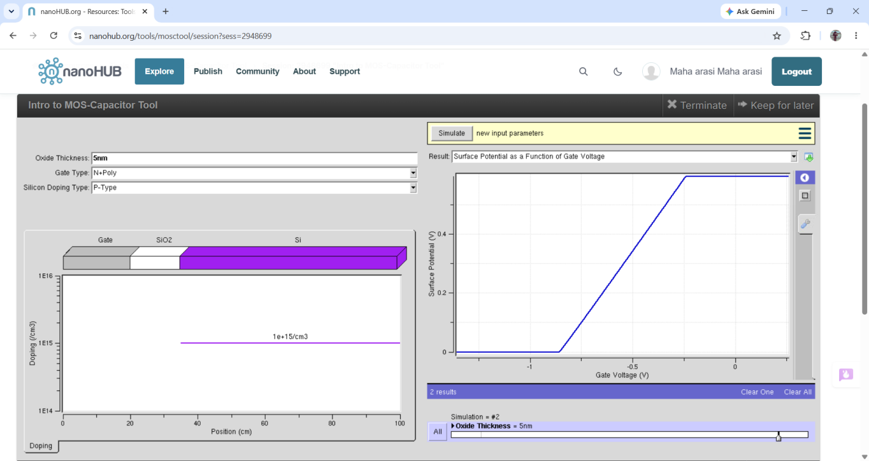

Output 3: Oxide Voltage as a Function of Gate Voltage — N+ Poly gate, P-type silicon.
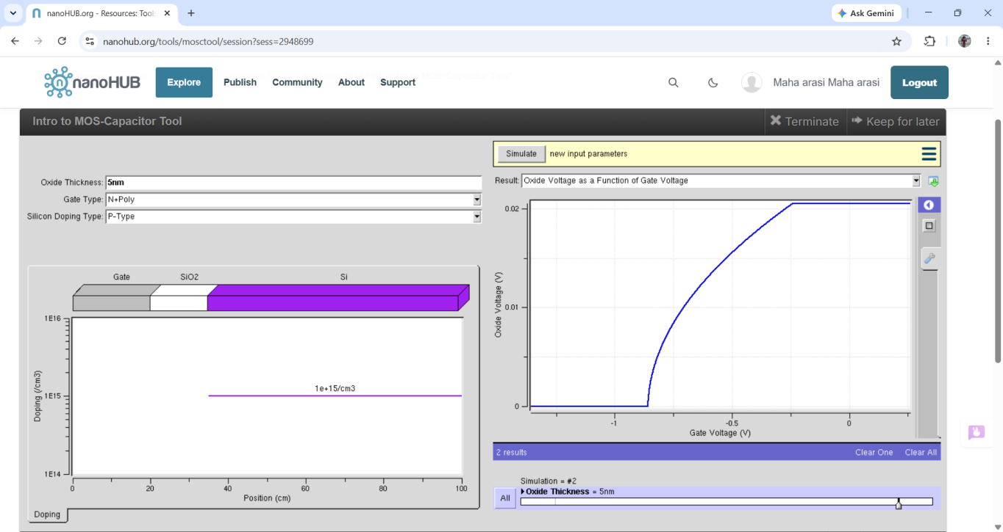

Output 4: Capacitance as a Function of Gate Voltage — N+ Poly gate, P-type silicon.
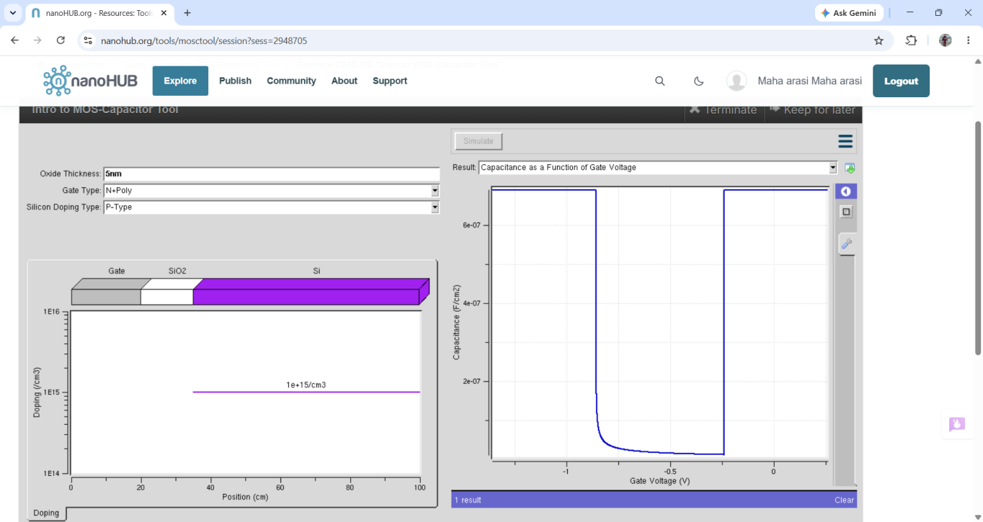

Output 5: Energy Band Diagram at Flatband Voltage — N+ Poly gate, P-type silicon.
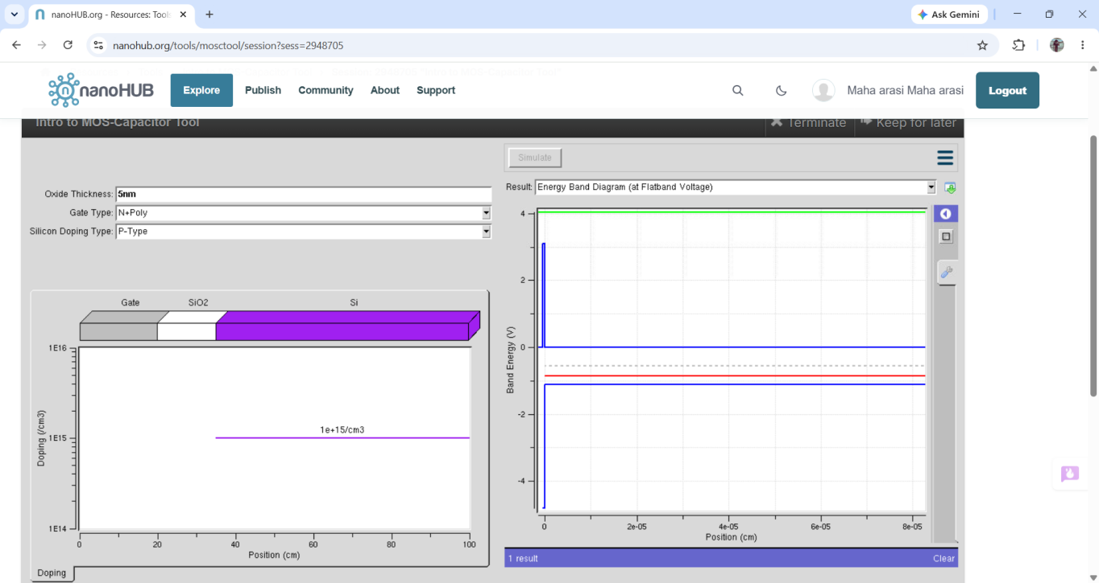

Output 6: Energy Band Diagram at Threshold Voltage — N+ Poly gate, P-type silicon.
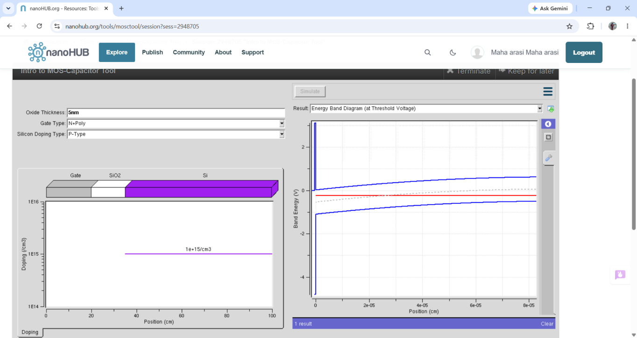

Output 7: Surface Potential as a Function of Gate Voltage — P+ Poly gate, N-type silicon.
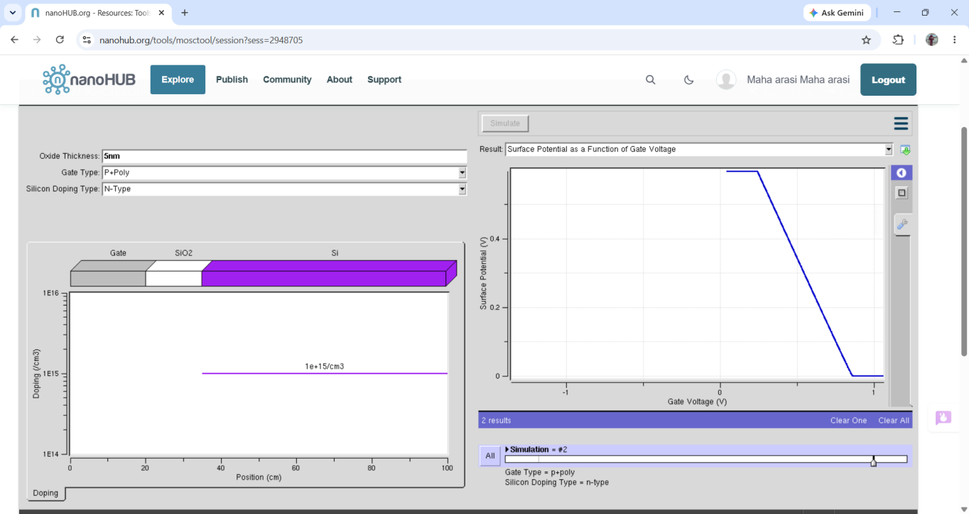

Output 8: Oxide Voltage as a Function of Gate Voltage — P+ Poly gate, N-type silicon.
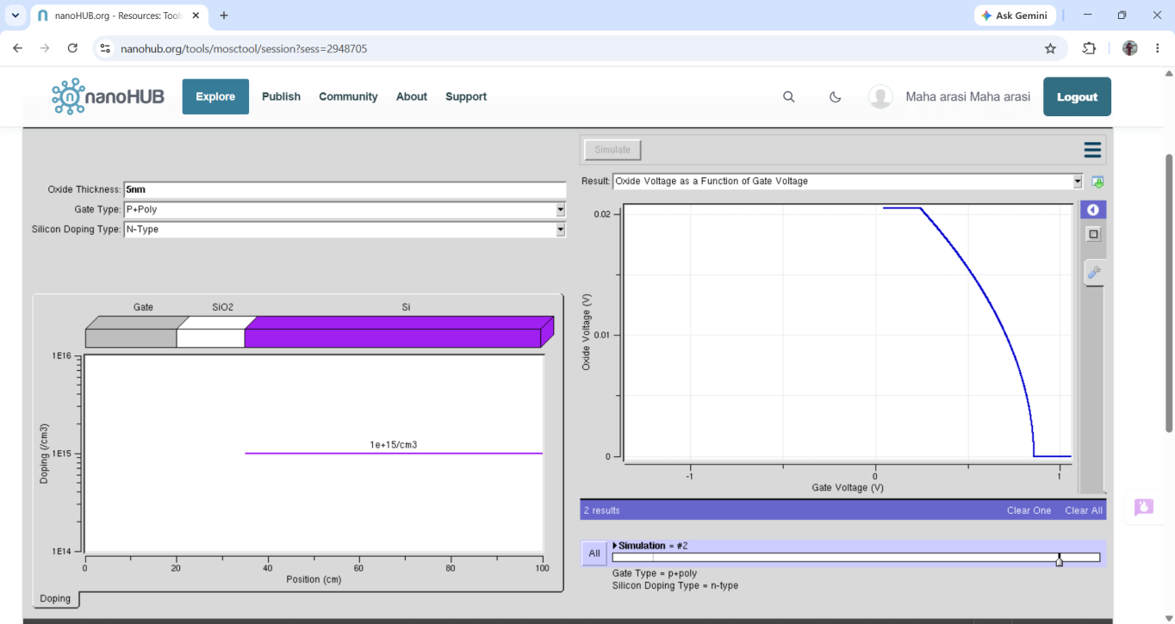

Output 9: Capacitance as a Function of Gate Voltage — P+ Poly gate, N-type silicon.
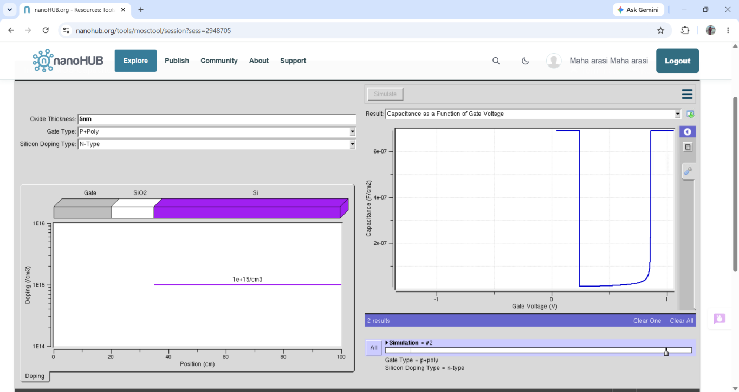

Output 10: Energy Band Diagram at Flatband Voltage — P+ Poly gate, N-type silicon.
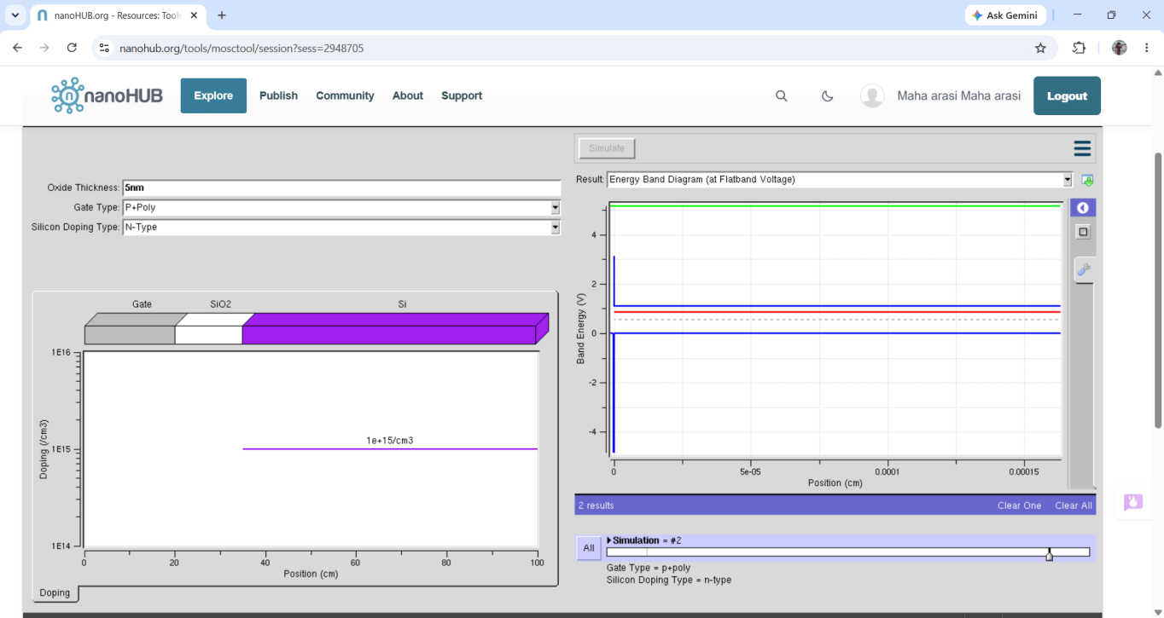

Output 11: Energy Band Diagram at Threshold Voltage — P+ Poly gate, N-type silicon.
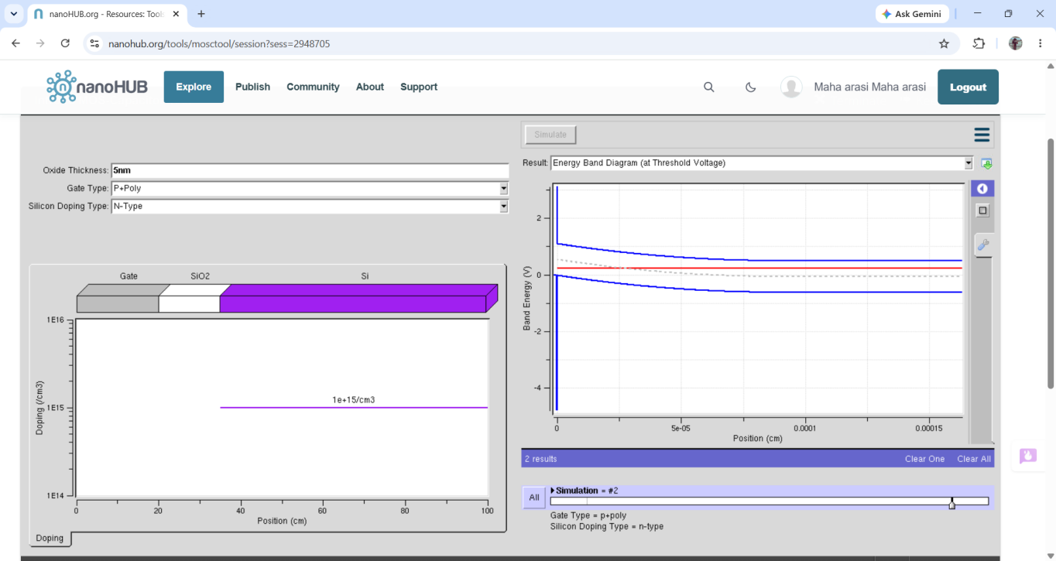

Observations
Only the observations and explanations are given in this section. The trends below are qualitative readings from the supplied simulator screenshots; exact numerical values are not stated where the graph scales are not clearly readable.

A. N+ Poly gate with P-type silicon substrate
1. Depletion width: The curve is near zero over part of the voltage range, then rises as the gate voltage moves in the direction that depletes holes. This occurs because the applied electric field pushes the majority carriers (holes) away from the silicon surface, leaving ionized acceptor atoms and forming a depletion region.
2. Surface potential: The surface-potential curve changes with gate voltage and then approaches a flatter region. Gate bias changes the semiconductor surface electric potential; once the surface charge response becomes stronger, the curve’s rate of change can reduce.
3. Oxide voltage: The oxide-voltage curve varies with gate voltage rather than matching it exactly. Some applied voltage drops across the oxide and some in the semiconductor. The division depends on the oxide capacitance and the charge/potential response of the substrate.
4. Capacitance: The capacitance changes with gate voltage. In depletion, the total small-signal capacitance is the series combination of oxide capacitance and depletion-region capacitance, so it is lower than the oxide capacitance alone. When the surface returns toward accumulation, capacitance can rise toward the oxide-capacitance value.
5. Flatband energy-band diagram: At flatband voltage, the semiconductor bands are approximately flat near the surface because the net band bending is removed. The required flatband voltage depends on the difference between the gate and semiconductor work functions and any oxide/interface charge.
6. Threshold energy-band diagram: At threshold, the surface band bending has reached the condition associated with strong inversion. For P-type silicon, a sufficiently positive gate bias attracts electrons toward the surface and can form an inversion layer.

B. P+ Poly gate with N-type silicon substrate
1. Surface potential: The surface-potential curve changes with gate voltage in the opposite bias direction compared with the P-type substrate case. This is because electrons, rather than holes, are the majority carriers in N-type silicon. The gate polarity needed to repel majority carriers and produce depletion is therefore reversed.
2. Oxide voltage: The curve shows how the applied voltage is shared between the oxide and the semiconductor. Its direction and operating points shift because both substrate type and gate work function differ from the first combination.
3. Capacitance: The capacitance again varies with gate voltage as the surface moves between accumulation, depletion, and inversion. For N-type silicon, negative gate bias generally repels electrons and forms depletion; stronger negative bias can eventually attract holes and create inversion. The capacitance curve therefore appears in a bias region opposite to that of the P-type substrate.
4. Flatband energy-band diagram: The flatband condition occurs at a gate voltage determined by the P+ polysilicon gate work function relative to the N-type silicon work function, plus any fixed/interface charge. Changing from N+ Poly/P-type silicon to P+ Poly/N-type silicon shifts the flatband condition.
5. Threshold energy-band diagram: For N-type silicon, strong inversion occurs when the surface is driven toward hole accumulation at the interface, which is typically achieved with a sufficiently negative gate voltage. Therefore, the threshold condition is on the opposite-polarity side from the P-type substrate case.

C. Why the results change when P-type/N-type and gate type are changed
• P-type versus N-type substrate: P-type silicon has holes as majority carriers, while N-type silicon has electrons. Reversing the substrate type reverses which gate-voltage polarity causes accumulation and which polarity causes depletion/inversion. As a result, the graph transitions shift or appear in the opposite voltage direction.
• N+ Poly versus P+ Poly gate: The two heavily doped polysilicon gates have different work functions. This changes the flatband voltage and shifts the voltage at which depletion, inversion, and threshold conditions occur.
• Combined effect: Changing both the gate material and substrate type changes the voltage offset as well as the polarity of the surface response. The general MOS principles remain the same, but the curves do not occur at identical gate voltages.
• Oxide thickness: The screenshots use 5 nm oxide. A thinner oxide gives a larger oxide capacitance per unit area (Cox = εox/tox), affecting how applied voltage is divided between oxide and semiconductor.
• Doping concentration: The shown substrate doping line is labelled 1 × 10¹⁵ cm⁻³ in the visible screenshot. Substrate doping affects depletion width and semiconductor capacitance; higher doping generally gives a narrower depletion region at a comparable surface potential.
The MOS-capacitor characteristics were simulated for N+ Poly/P-type silicon and P+ Poly/N-type silicon configurations at 5 nm oxide thickness. The supplied plots demonstrate that substrate type and gate work function affect the voltage polarity and operating points for depletion, surface potential, oxide voltage, capacitance, flatband, and threshold conditions.
The experiment shows that MOS-capacitor behaviour depends on gate voltage, gate work function, substrate doping type, and oxide thickness. P-type and N-type substrates respond differently because their majority carriers are different, while N+ and P+ polysilicon gates shift the flatband and threshold voltages because of their different work functions. The attached outputs provide a qualitative comparison of these effects.

